PART D Q2 Demonstrate Telnet Vulnerabilities through Packet Capture

Problem Statement
Configure R0 as a Telnet server and R1 as a Telnet client.
From R1, initiate a Telnet session to R0 and capture the session in Cisco Packet Tracer Simulation Mode.Locate and document the plaintext username and password within the Telnet application payload (with screenshots).Finally, explain why Telnet credentials are exposed and outline the secure remediation steps (disable Telnet and enable SSH).

OUPUT & CONFIG:
Layout and Router configuration:
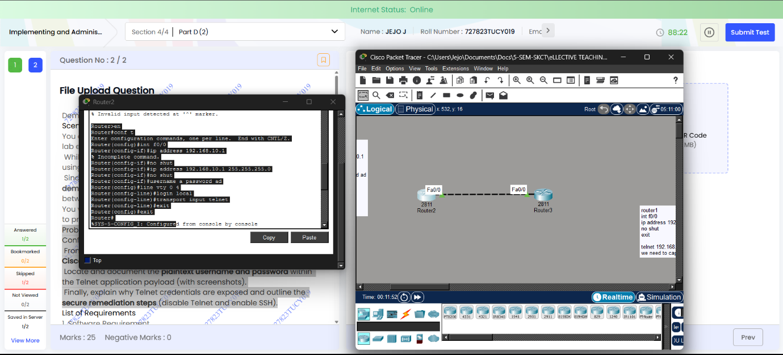
Trying to connect with telnet and packet capturing:
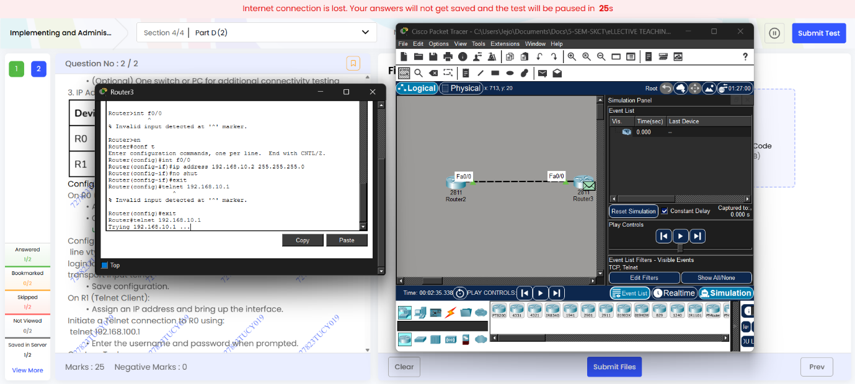
Captured packet vulnerability:
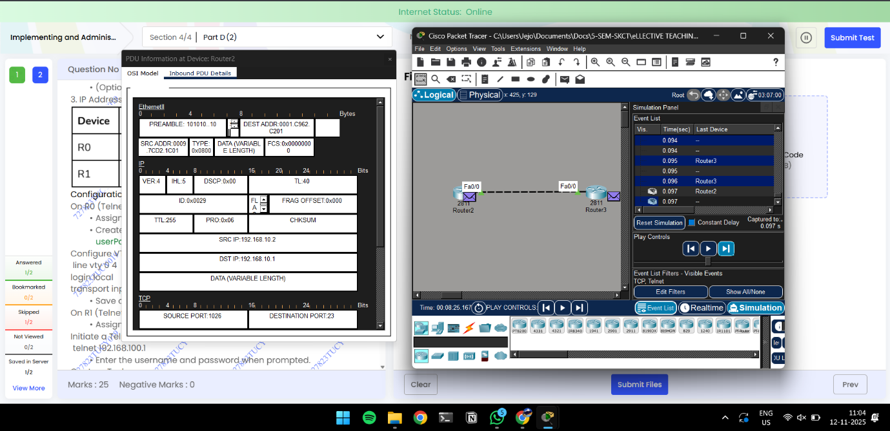
Why?
Since telnet is not encryted the password and session can be viewed by just capturing once network packet and session can be manipulated or sensitive data can be extracted
Final telnet connection:
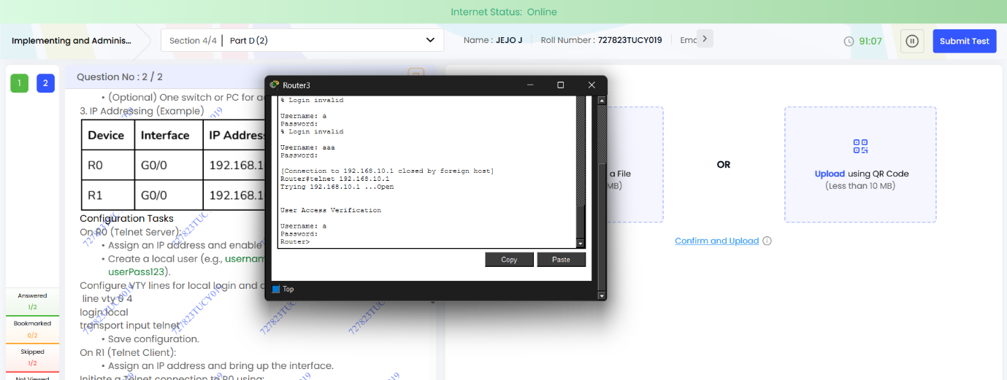

Name: Jejo J
Roll: 727823tucy019

